Lucas Swanson
4/26/2025
Software Engineering Methods
Exercise 4.2
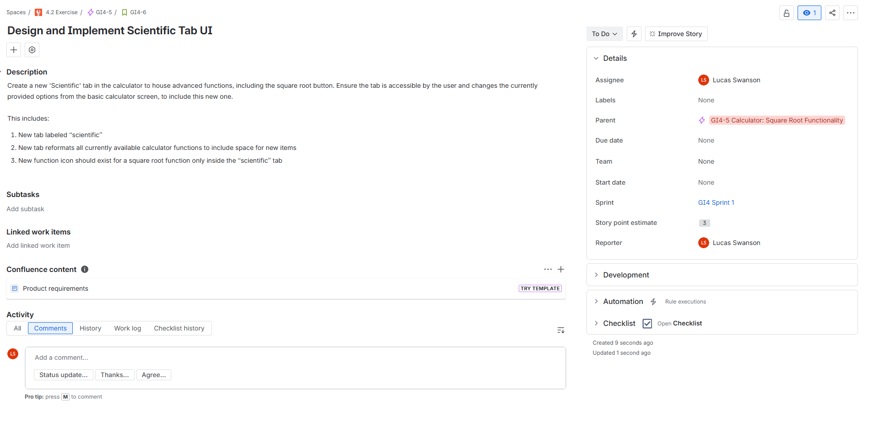
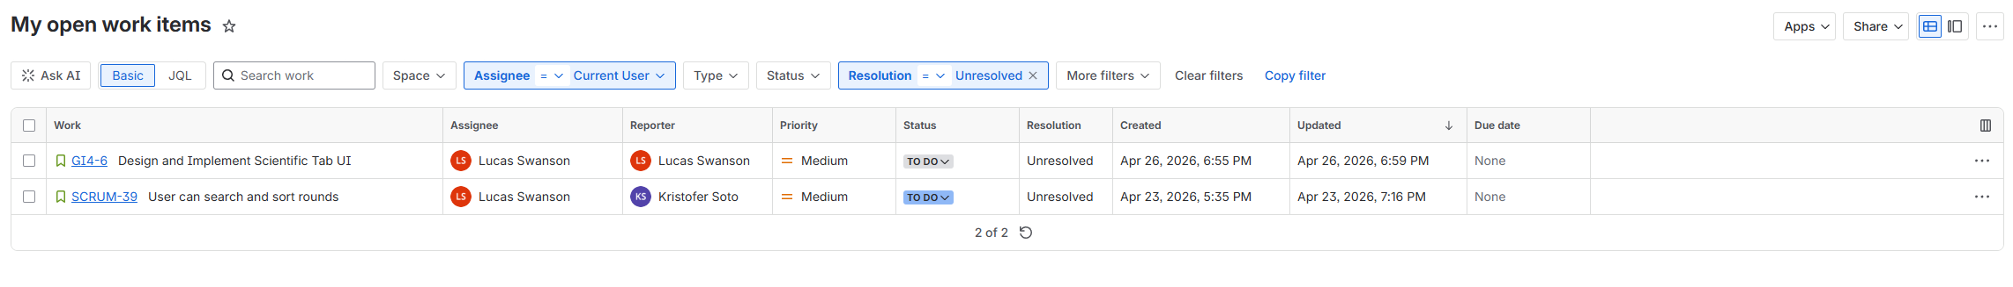
- Useful features: Based on your exploration, which one Jira feature do you think will personally find to be most valuable, and why?
  - I will definitely find the “My open work items” the most valuable to me because it is a reliable way to find what I currently have assigned to me when planning my work for the day. In the photo I can see the story I made for myself in the epic for this as well as the story assigned to me for the group project I am in.
- Surprises or friction: Was there anything about Jira that surprised you, confused you, or worked differently than you expected?
  - All of the menus can be a bit overwhelming. I think most users might stick to only a few different tabs or views (such as viewing my currently assigned items, current sprint, and items in my teams backlog), and ignore everything else. This may be a bit cumbersome for most.
- Connection to agile: How does what you saw in Jira connect to the agile concepts you studied in Weeks 1 and 2 (e.g., sprints, backlog, story points, epics)?
  - This organizes all of what was discussed into one website location meant for tracking all of these aspects of agile concepts. It allows tickets to be made with all required fields for estimating work, providing descriptions of desired completeness of the project / task. Provides the ability to link action items to a story, stories to epics, and plan out timelines for epics.
- Open question (optional): What is one thing about Jira you would like to understand better after this exploration?
  - I want to know what is the proper format for sequencing stories within an epic. For example, how would I indicate that one story enables another to work? How do I make it obvious to the user that something has to be done in a sequential order. I saw that we can link child issues, or make something blocked by another, but neither of those seem like the right way to do it.

